**CHAPTER 1**

**INTRODUCTION**

The most basic form of cloud storage allows users to upload individual files or folders from their personal computers to a central Internet server. This allows users to make backup copies of files in case their originals are lost.

Users can also download their files from the cloud to other devices, and sometimes also enable remote access to the files for other people to share. Today, things are moving off the device and into the cloud. The rise of cloud service adoption is making us move to a secure digital workspace platform, swapping desktops for internet browsers.

In this project we discuss the result of the work done in development of "Urbox” on “HTM & PHP” as the Front-end Platform and “Mongo DB” as the back-end Platform.

At the development of an application PHP provides a good connecting facility between all pages, also the back-end Mongo DB is most important to save all the data related the application.

**CHAPTER 2**

**SYSTEM ANALYSIS**

**2.1 Literature Survey**

Urbox, at its core, offers free online storage space accessible from any Internet-connected device. Students with Internet access can easily save and store every class paper they produce (or scan in) on Urbox. Student work remains on their hard drive but is automatically backed up to the cloud. Urbox is an innovative hybrid of Software as a Service (SaaS) which works in partnership with your own computer while keeping the software updated from the Internet. Students, perhaps for the first time, can safely wean themselves from carrying a USB thumb drive if they choose to use Urbox.

**2.1.1 Existing System**

Inthe existing system the users store their information in hard drives or other disks which makes the entire process of storing process distributive. User needs to access the same data in multiple devices and gathering whole data is time and space consuming. If a storage unit fails the chances of recovery are next to none.

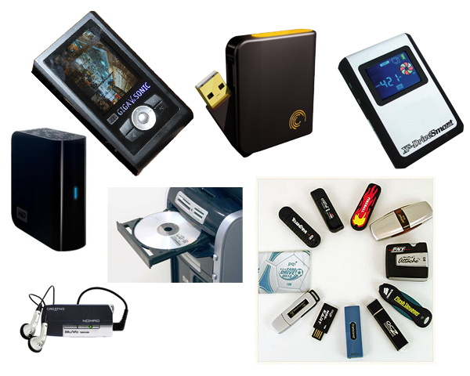

**2.2 Proposed System**

The proposed system will be having all the following activities which will centralize the user data to a single server that can be accessed from multiple devices. This system maintains user’s name, email id, contact.

This system will provide server storage facilities and services which is required by the user and various controls provided by system rich user interface Authentication is

provided for this application only registered user can access the service and any time a

new user can sign up this system, which makes the process easy and less time consuming.

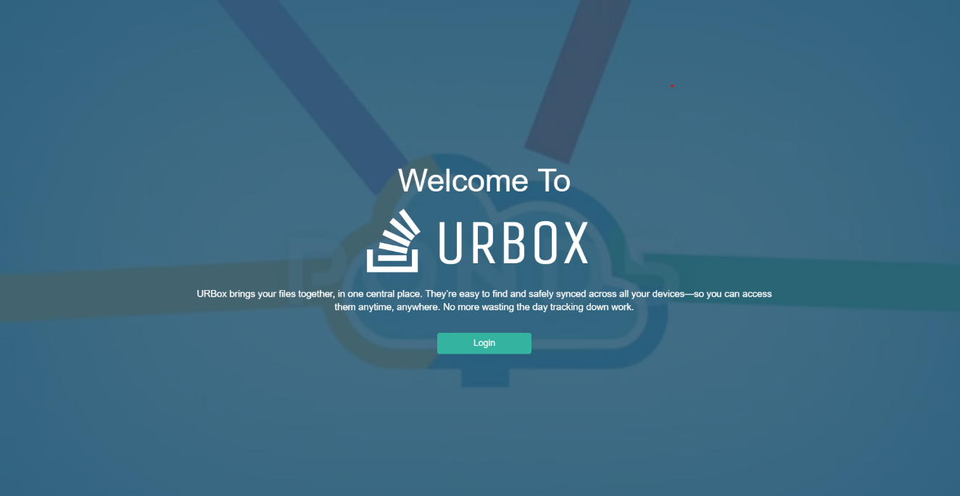

**2.2.1 Scope of the Project**

* To review the cloud computing technology and the data storage process across the cloud computing
* To review the client requirements with respect to their reliability and security of their data stored

**2.2.2 Aim of the Project:**

* To review the client requirements with respect to their reliability and security of their data stored

-

* Cut the operational costs: An important objective is reduction of operational costs, which you can achieve by choosing a low-maintenance platform. By migrating
* your data and resource to a cloud storage platform you benefit from free support, reducing the total costs of maintenance

**CHAPTER 3**

**REQUIRED SPECIFICATION**

**3.1. System Requirement**

**3.1.1 Hardware Configuration:**

**Processor : Intel core**

**Processor Speed : 2.4 GHz onwards**

**Ram Size : 4 GB Ram and above**

**Hard Disk :40 GB and above**

**3.1.2 Software Configuration:**

**Operating System : Windows 10**

**Software :notepad++**

**Server :WampApache Server**

**Database :Mysql 5.3.1**

**Front End :HTML,JS,CSS**

**Back End :PHP5.3.4**

**3.2 Development Environment**

**Hypertext Markup Language(HTML)**

**\*** HTML stands for Hypertext Mark-up Language, it is the standard mark-up

language for creating web pages and web applications.

* JavaScript, it forms a triad of cornerstone technologies for the World Wide Web.

* Web browsers receive HTML documents from a web server or from local storage

and render them into multimedia web pages. HTML describes the structure of a

web page semantically and originally included cues for the appearance of the

document.

* HTML elements are the building blocks of HTML pages, with HTML constructs,

images and other objects, such as interactive forms, may be embedded into the

rendered page.

* It provides a means to create structured documents by denoting structural

semantics for textsuch as headings, paragraphs, lists, links, quotes and other items.

HTML elements are delineated by tags, written using angle brackets. Browsers do

not display the HTML tags, but use them to interpret the content of the page.

**Cascading Style Sheets (CSS)**

* It is a style sheet language used for describing the presentation of a document

written in a mark-up language. Although most often used to set the visual style of

web pages and user interfaces written in HTML, the language can be applied to

any document, including plain XML, SVG and XUL, and is applicable to

rendering in speech, or on other media [3].

* Along with HTML and JavaScript, CSS is a cornerstone technology used by most

websites to create visually engaging webpages, user interfaces for web

applications, and user interfaces for many mobile applications.

* CSS is designed primarily to enable the separation of presentation and content,

including aspects such as the layout, colours, and fonts. This separation can

improve content accessibility, provide more flexibility and control in the

specification of presentation characteristics, enable multiple HTML pages to share

formatting by specifying the relevant CSS in a separate .CSS file, and reduce

complexity and repetition in the structural content. Separation of formatting and

content makes it possible to present the same markup page in different styles.

**JavaScript**

* It is often abbreviated as JS, is a high-level, dynamic, weakly typed, prototype-

based, multi-paradigm, and interpreted programming language.

* Alongside HTML and CSS, JavaScript is one of the three core technologies of

World Wide Web content production. It is used to make webpages interactive and

provide online programs, including video games.

* Most websites employ it, and all modern web browsers support it without the need

for plug-ins by means of a built-in JavaScript engine. Each of the many JavaScript

engines represent a different implementation of JavaScript, all based on the

ECMAScript specification, with some engines not supporting the spec fully, and

with many engines supporting additional features beyond ECMA.

* As a multi-paradigm language, JavaScript supports event-driven, functional, and

imperative programming styles. It has an API for working with text, arrays, dates,

regular expressions, and basic manipulation of the DOM, but the language itself

does not include any I/O, such as networking, storage, or graphics facilities,

relying for these upon the host environment in which it is embedded.

* Initially only implemented client-side in web browsers, JavaScript engines are

now embedded in many other types of host software, including server-side in web

servers and databases, and in non-web programs such as word processors and PDF

software, and in runtime environments that make JavaScript available for writing

mobile and desktop applications, including desktop widgets.

**Hypertext pre-processor(PHP)**

* It is a server-side scripting language designed primarily for web development but

also used as a general-purpose programming language.

* PHP was originally created by Rasmus Lerdorf in 1994, the PHP reference

implementation is now produced by The PHP Development Team.

* PHP stands for the acronym: Hypertext Pre-processor.

* PHP code may be embedded into HTML or HTML5 mark-up, or it can be used in

combination with various web template systems, web content management

systems and web frameworks.

* PHP code is usually processed by a PHP interpreter implemented as a module in

the web server or as a Common Gateway Interface (CGI) executable. The web

server software combines the results of the interpreted and executed PHP code,

which may be any type of data, including images, with the generated web page.

PHP code may also be executed with a command-line interface (CLI) and can be

used to implement standalone graphical applications.

* The standard PHP interpreter, powered by the Zend Engine, is free software

released under the PHP License. PHP has been widely ported and can be deployed

on most web servers on almost every operating system and platform, free of

charge.

**MySQL Server**

* It is an open-source relational database management system(RDBMS). Its name is

a conditional of “My”, the name of co-founder Michael Widenius daughter, and

“SQL”, the abbreviation for Structured Query Language. [4]

* The MySQL development project has made its source code available under the

terms of the GNU Public Licence, as well as under a variety of proprietary

agreements.

* MySQL was owned and sponsored by a single for-profit firm, the Swedish

company MySQL AB, now owned by Oracle Corporation. For prosperity use,

several paid editions are available, and offer additional functionality.

* The MySQL server package will install the MySQL database server which can

interact with using a MySQL client. User can use the MySQL client to send

commands to any MySQL server; on a remote computer.

**CHAPTER 4**

**SYSTEM DESIGN**

**4.1 ER Diagram**

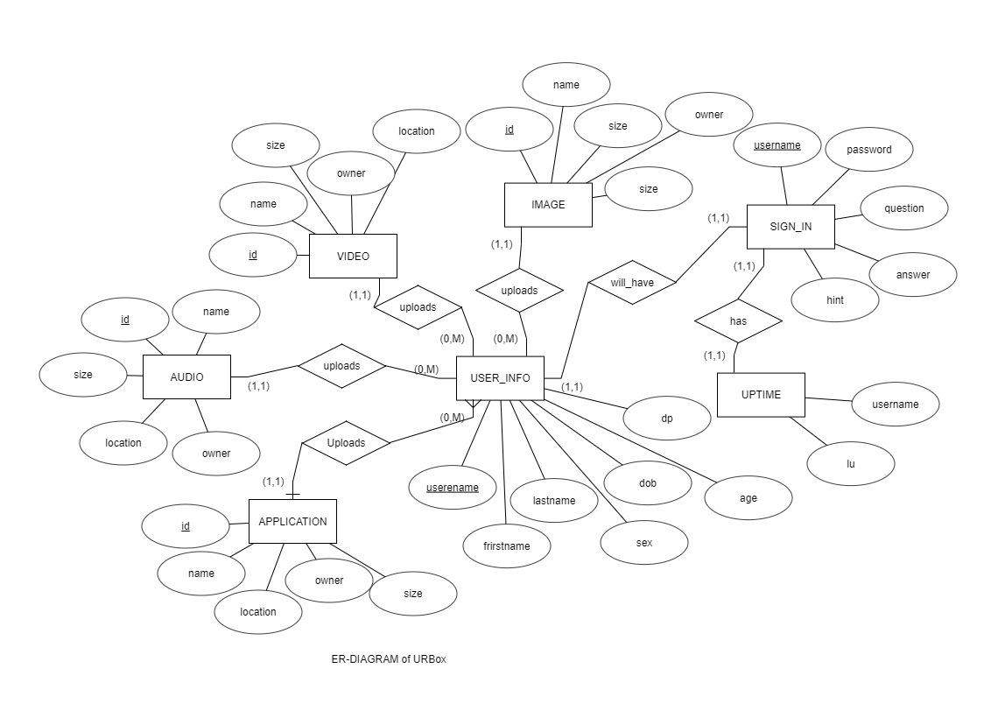

**Figure 4.1: ER Diagram**

An Entity-Relationship Diagram (ERD) is a data modelling technique that graphically illustrates an information system’s entities and the relationships between those entities. An ERD is a conceptual and representational model of data used to represent the entity framework infrastructure.

The ER Diagram shown in figure 2.2 consists of 7 attributes namely

1. APPLICATION
2. AUDIO
3. VIDEO
4. USER_ID
5. SIGN_IN
6. IMAGE
7. UPTIME

**4.2 Schema Diagram**

APPLICATION

|  |  |  |  |  |
| --- | --- | --- | --- | --- |
| ID | NAME | SIZE | OWNER | LOCATION |

AUDIO

|  |  |  |  |  |
| --- | --- | --- | --- | --- |
| ID | NAME | SIZE | OWNER | LOCATION |

IMAGE

|  |  |  |  |  |
| --- | --- | --- | --- | --- |
| ID | NAME | SIZE | OWNER | LOCATION |

VIDEO

|  |  |  |  |  |
| --- | --- | --- | --- | --- |
| ID | NAME | SIZE | OWNER | LOCATION |

USERINFO

|  |  |  |  |  |  |  |  |
| --- | --- | --- | --- | --- | --- | --- | --- |
| USERNAME | FIRST_NAME | LAST_NAME | EMAIL | SEX | AGE | DOB | DP |

SIGN_IN

|  |  |  |  |  |
| --- | --- | --- | --- | --- |
| USERNAME | PASSWORD | QUESTION | ANSWER | HINT |

UPTIME

|  |  |
| --- | --- |
| USERNAME | UL |

**Figure 4.2: Schema Diagram**

The logical mapping of ER diagram to relational model is shown in Figure 2.3.

**CREATE SYNTAX**

**Create table application** (

Id varchar (50),

Name varchar(50),

Size varchar(50),

Owner varchar(50),

Location varchar(50));

**Create table audio** (

Id varchar (50),

Name varchar(50),

Size varchar(50),

Owner varchar(50),

Location varchar(50));

**Create table video** (

Id varchar (50),

Name varchar(50),

Size varchar(50),

Owner varchar(50),

Location varchar(50));

**Create table image** (

Id varchar (50),

Name varchar(50),

Size varchar(50),

Owner varchar(50),

Location varchar(50));

**Create table user_info**(

username varchar (50),

First_name varchar(50),

Last_name varchar(50),

Email varchar(50),

Sex varchar(50),

Dob date,

Age varchar(50),

Dp varchar(50) );

**Create table sign_in** (

username varchar(20),

password varchar(50),

question varchar(100),

answer varchar( 50),

hint varchar(50));

**create table uptime** (

Username varchar(20),

Ul timestramp);

**INSERTION**

**Insert into application values**(‘&id’,’&name’,’&size’,’&owner’,’&location’);

**Insert into audio values**(‘&id’,’&name’,’&size’,’&owner’,’&location’);

**Insert into image values**(‘&id’,’&name’,’&size’,’&owner’,’&location’);

**Insert into video values**(‘&id’,’&name’,’&size’,’&owner’,’&location’);

**Insert into user_info values**(‘&username’,’&first_name’,’&last_name’,’&email’,’&sex’, &age,’&dob’,’&dp’);

**Insert into sign_in values** (‘&username’,’&password’,’&question’,’&answer’,’&hint’);

**Insert into uptime values**(‘&username’,’&lu’);

**CHAPTER 5**

**Module Implementation**

To implement this project, MYSQL is used for backend and HTML5 & CSS3 is used for frontend (GUI) creation.

**5.1. Module Description**

The modules included in this project are:

**1. Login**

**DESCRIPTION:**

Front end is designed using html &css.

Login page provides 2 textboxes to enter username and password, on entering the user shall click on submit button, on clicking submit button, a form action will call the associated php script.

If the entered username and password matches with registered details, the user will be taken to home page, otherwise error message will be displayed in the same page, user will be asked to enter username and password again.

1. **Uploading Files.**

**DESCRIPTION:**

Front end is designed using html & css.

Uploading files provides one browse button to browse files from desktop for uploading, once the user choose a file, it will be appeared in a label on entering the user shall click on upload button, on clicking upload button, a from action will call the associated php script.

If the size of the file is more than 5 MB the user will get an error message saying the file is too big and it cannot be uploaded.

1. **File view**

**DESCRIPTION:**

Front end is designed using html & css.

User home page provides Table, which list out the detail of the files, on clicking view, download or delete button will call the respective php script.

1. **Gallery.**

**DESCRIPTION:**

Front end is designed using html & css.

The gallery page provides a thumbnail of the image or the video files uploaded by the user. A view button can be clicked to expand the image to its full size or play the video with video controls. Download and delete buttons will call the respective php scripts.

1. **Security Information View.**

**DESCRIPTION:**

Front end is designed using html & css.

It provides basic security information in the form of an html form and allows user to edit the existing security details by clicking on submit button which will call the respective php script.

1. **Edit Information page.**

**DESCRIPTION:**

Front end is designed using html & css.

It provides basic user information in the form of an html form and allows user to edit the existing user details by clicking on submit button which will call the respective php script.

1. **Sign up page.**

**DESCRIPTION:**

Front end is designed using html & css.

It consists of multiple labels and textboxes regarding different information about the user. Signup button will call the respective php script.

**CHAPTER 6**

**CONCLUSION & FUTURE WORKS**

**6.1 Conclusion:**

This work is a humble venture to satisfy all the needs of a user who wants to store data in cloud. Several userfriendly codes have been adopted. This project shall prove to be a powerful package which satisfies all the requirements of user **.**

**6.2 Future works:**

a) The project shall host the platform on online servers to make is accessible worldwide.

b) The project shall integrate multiple load balancers to distribute loads on system.

c) The project shall include a master-slave database structure to reduce overload on

databases on regular basis on different servers.

**CHAPTER 7**

**RESULTS AND SCREENSHOTS**

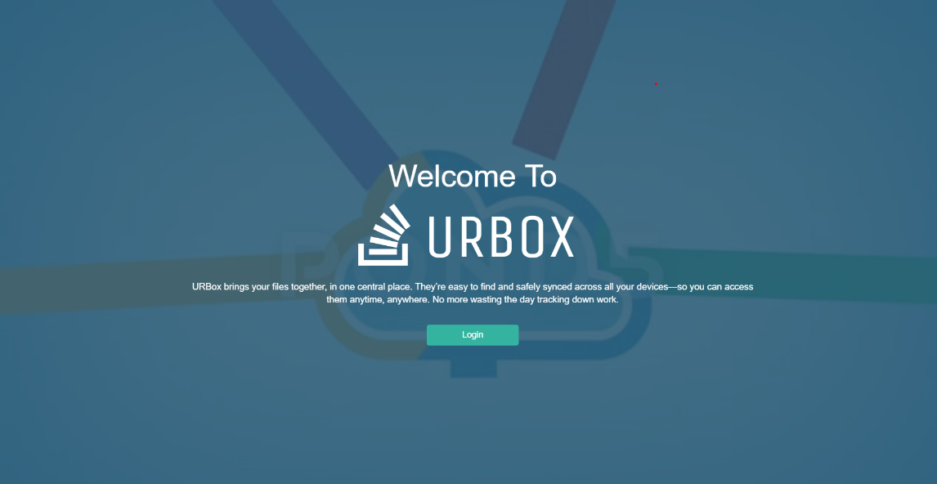

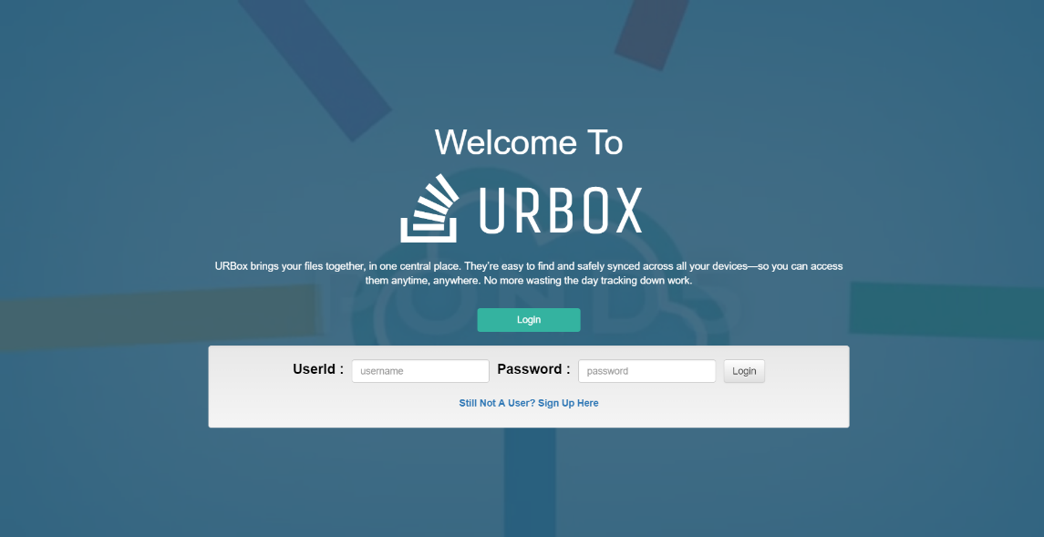

**Sign In Page**

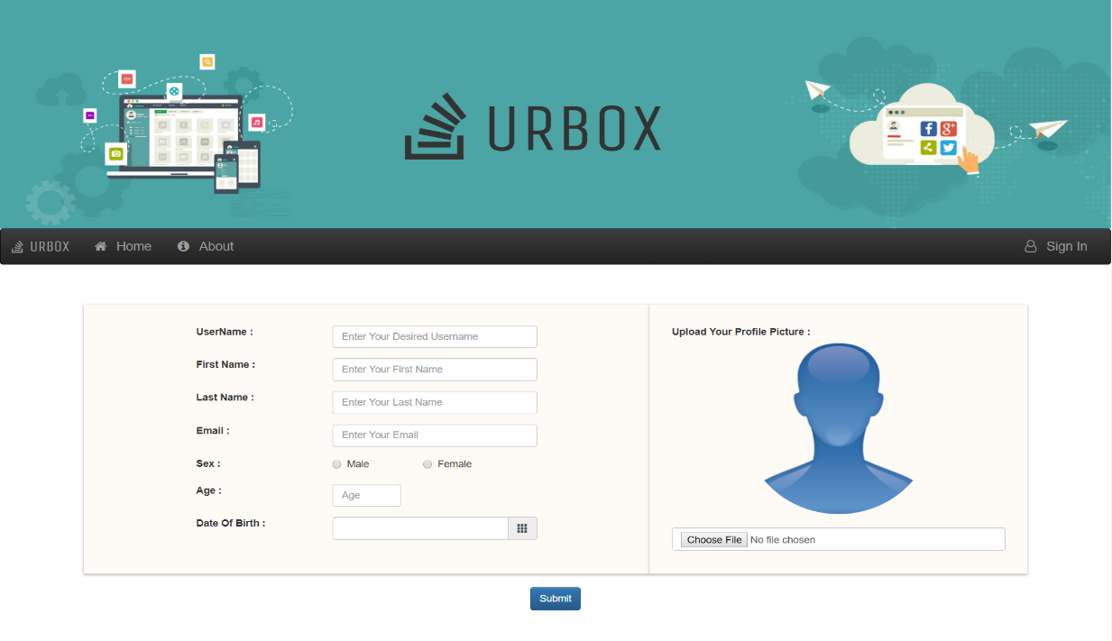

**Sign up Page**

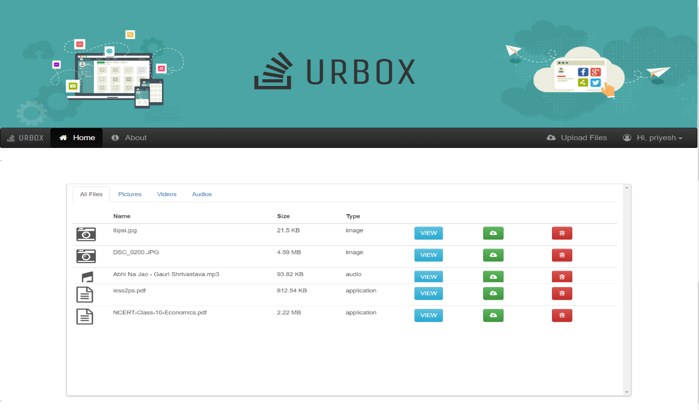

**User Home Page**

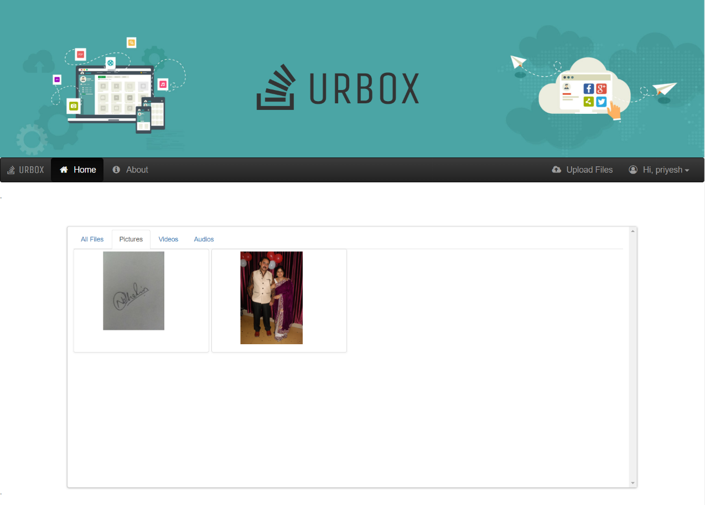

**Home Page #Image Tab**

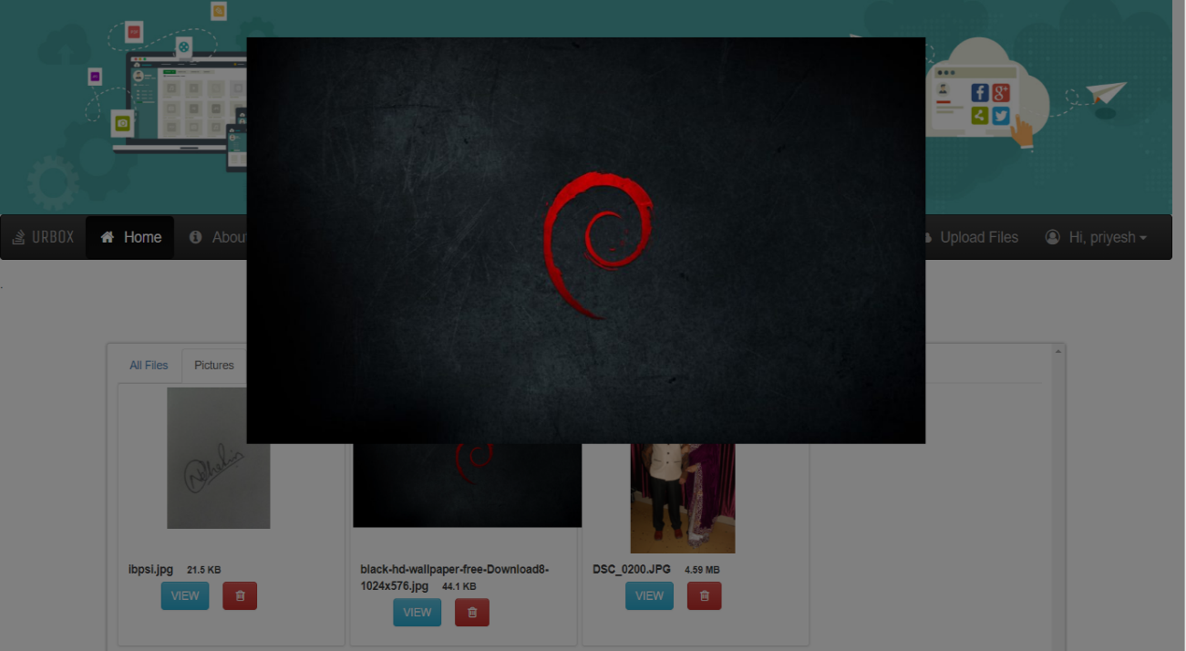

**Home Page #Image View**

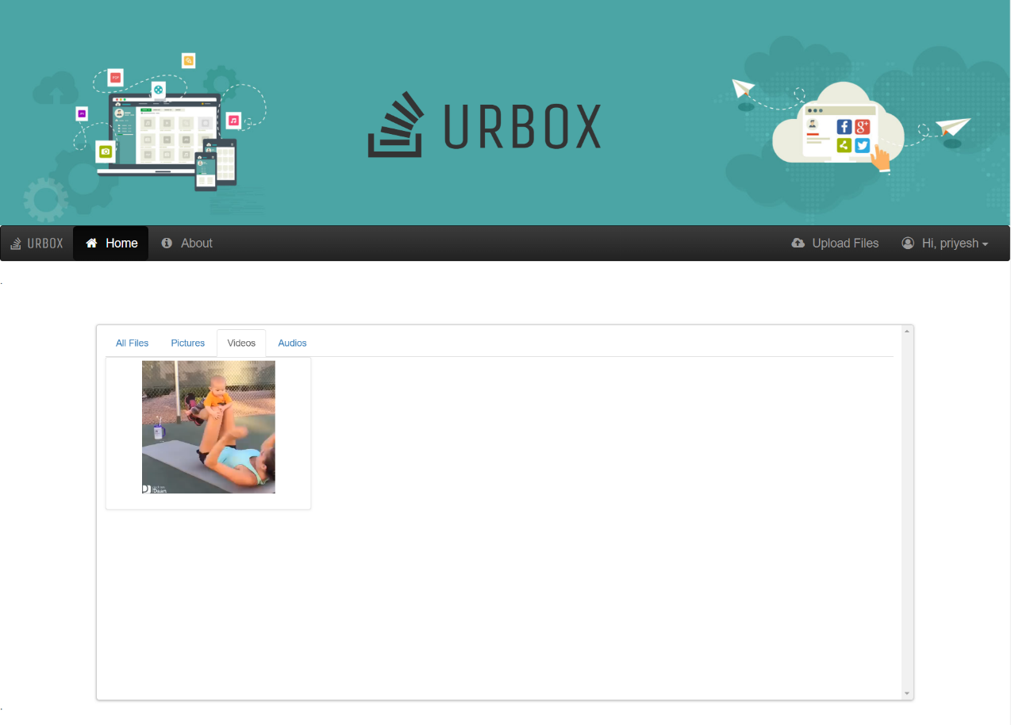

**Home Page #Video Tab**

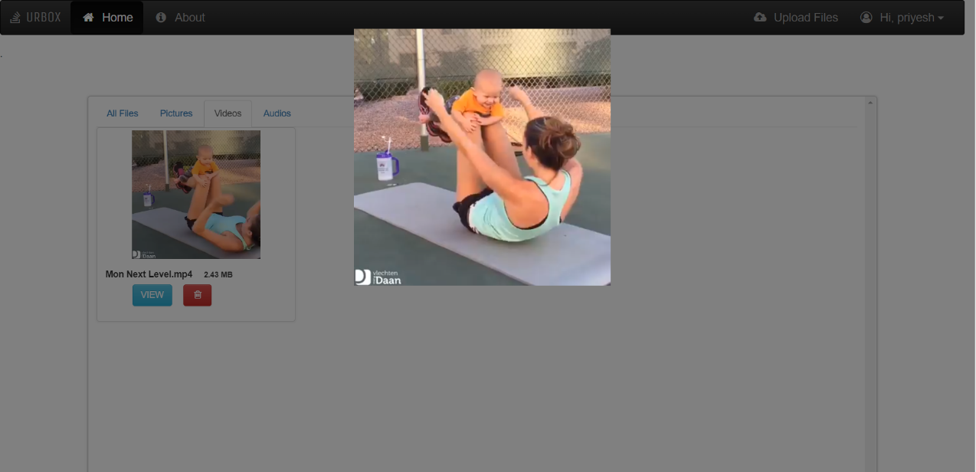

**Home Page #Video View**

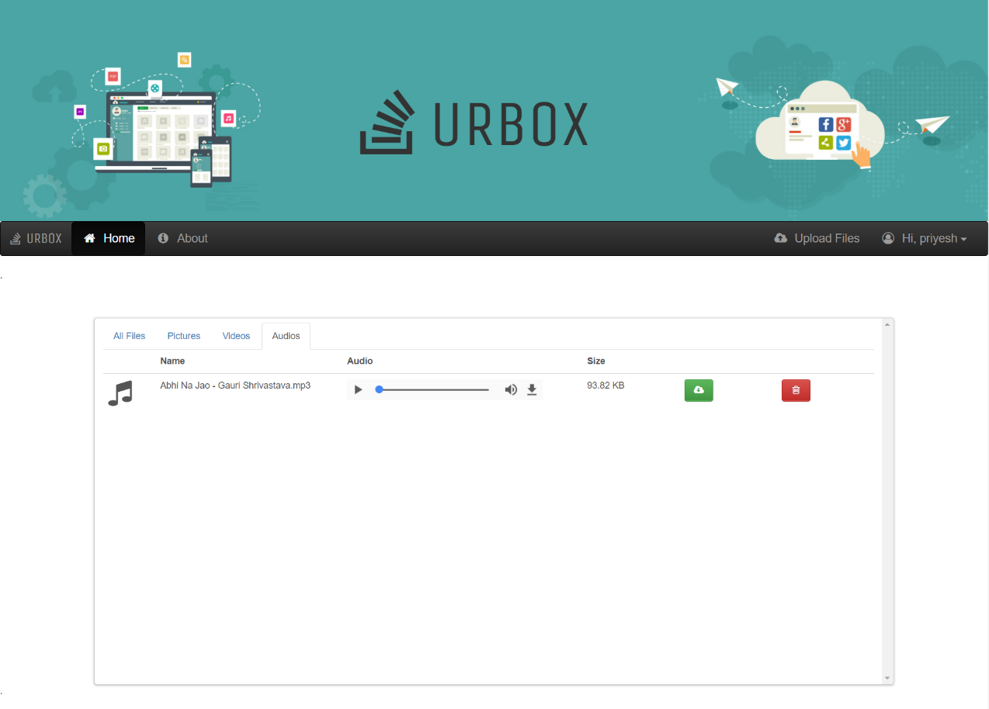

**Home Page #Audio Tab**

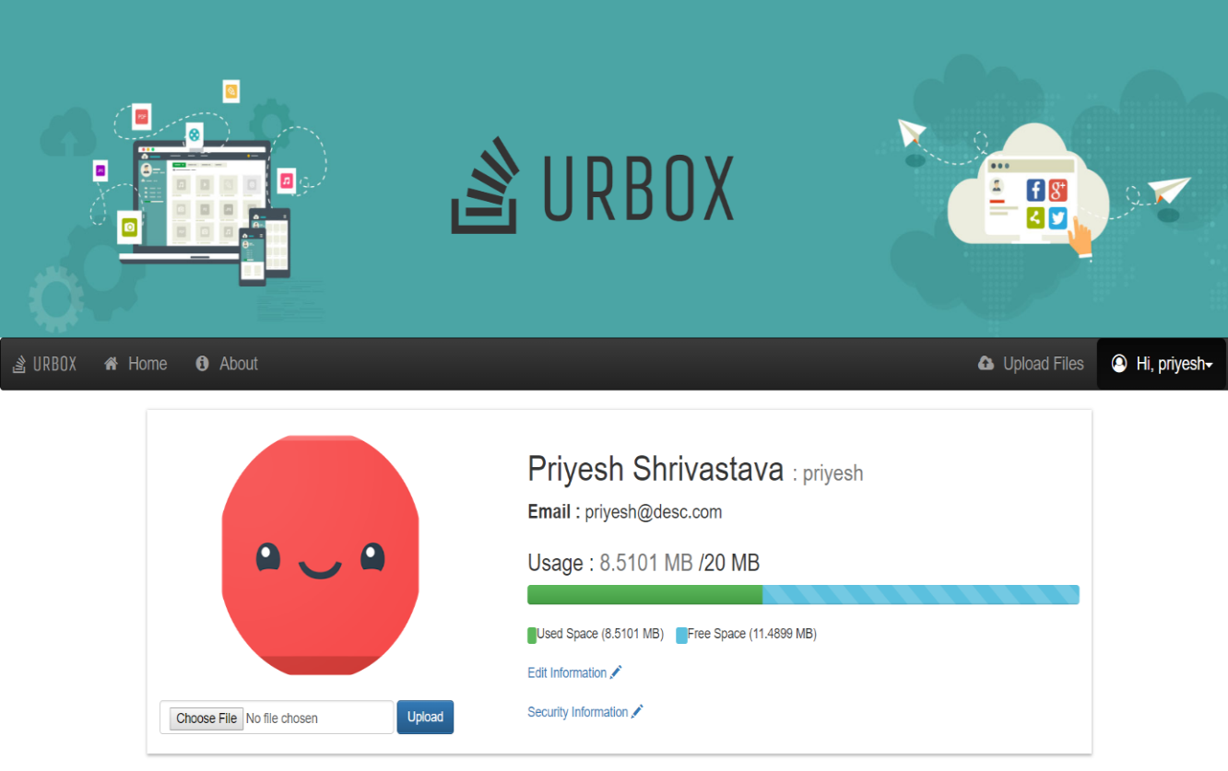

**User Info Page**

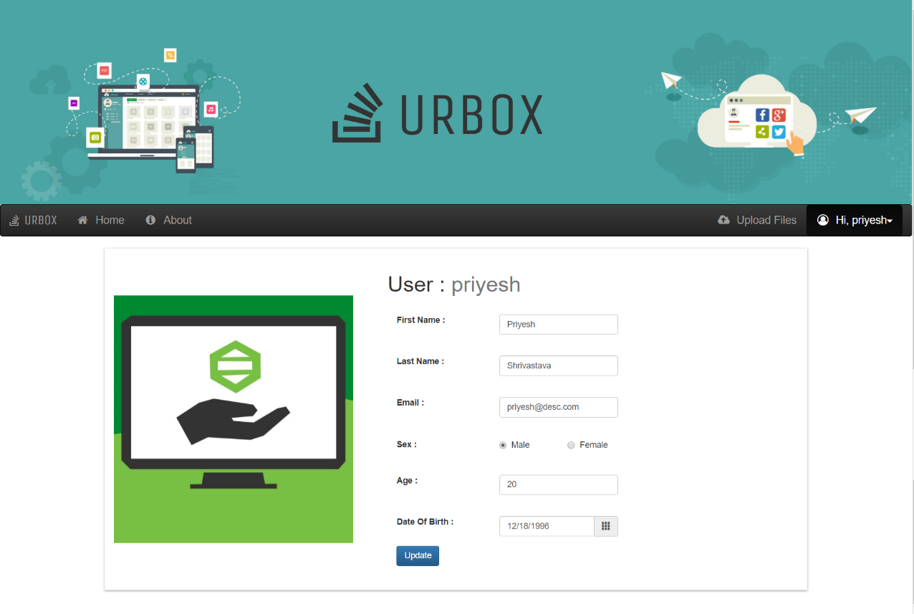

**User Info Edit Page**

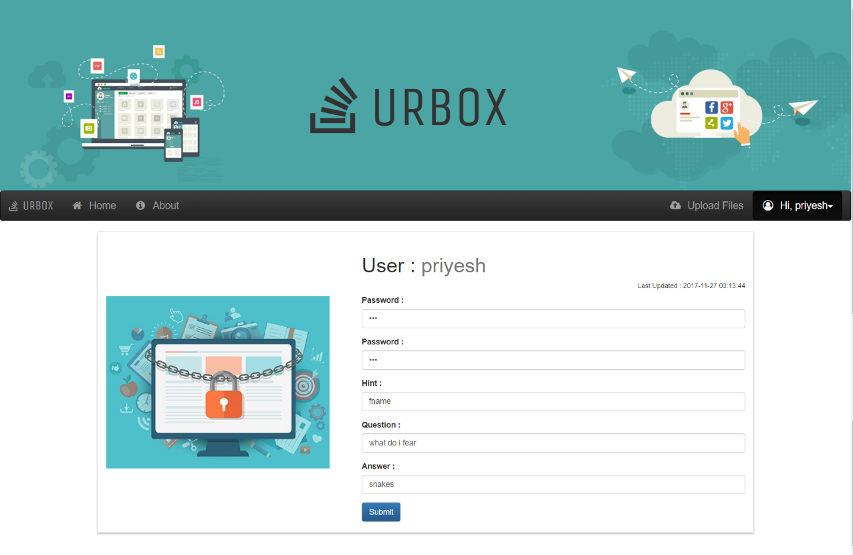

**User Security Info Edit Page**

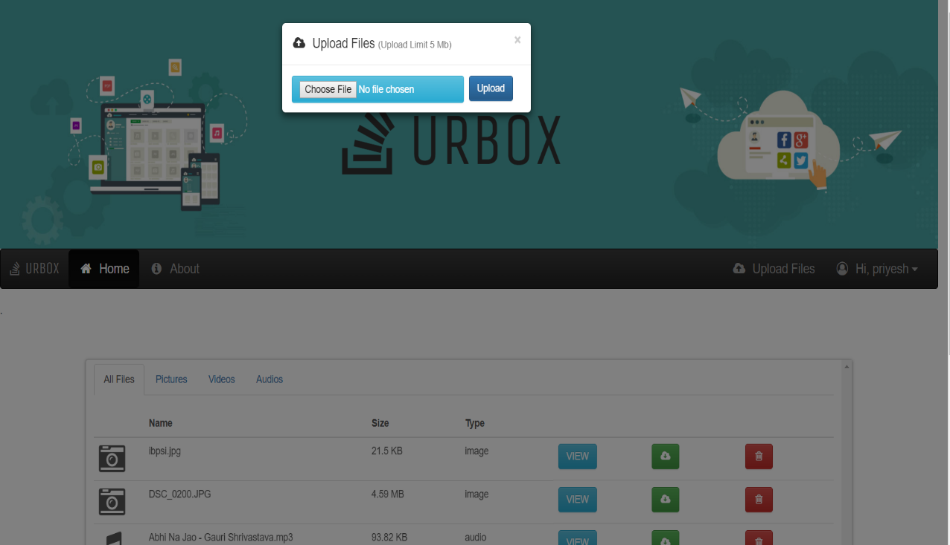

**Home Page #Upload Modal**

**BIBLIOGRAPHY**

[1] Fundamentals of Database Systems, Ramez Elmasri and Shamkant B. Navathe, 7th Edition, 2017, Pearson

[2] [www.stackoverflow.com](http://www.stackoverflow.com)

[3] [www.youtube.com](http://www.youtube.com)

[4] [www.scribd.com](http://www.scribd.com)

[5] [www.tutorialpoint.com](http://www.tutorialpoint.com)

[6] Database management systems, Ramakrishnan, and Gehrke, 3rd Edition 2014, McGraw Hill

[7] www.w3schools.com